Goto <https://www.oracle.com/java/>

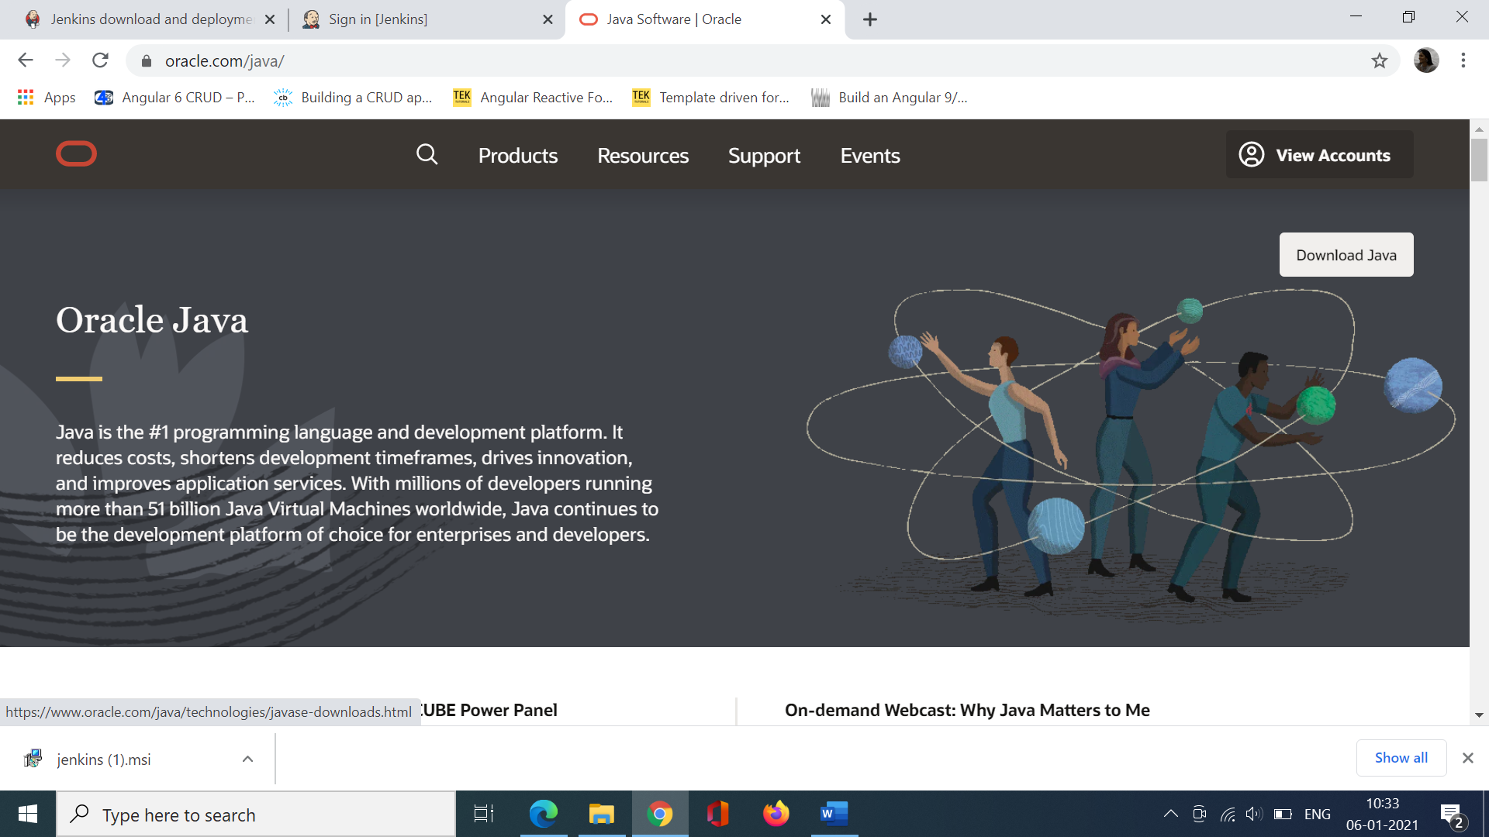

Go to this link:

https://www.oracle.com/java/technologies/downloads/#java11-windows

Jenkins supports JDK 11 only. So download jdk 11 .

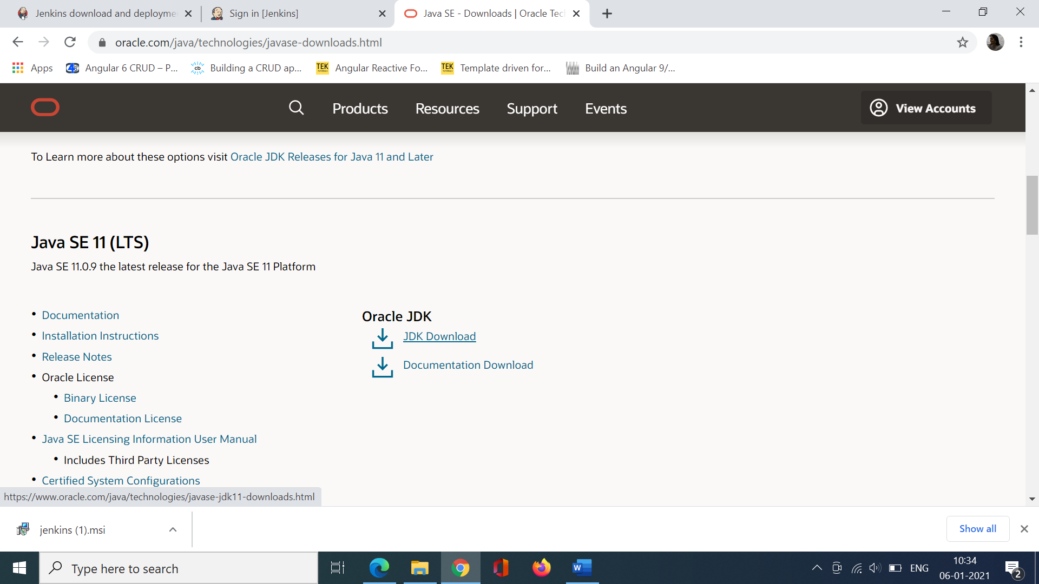

Choose Windows 64.

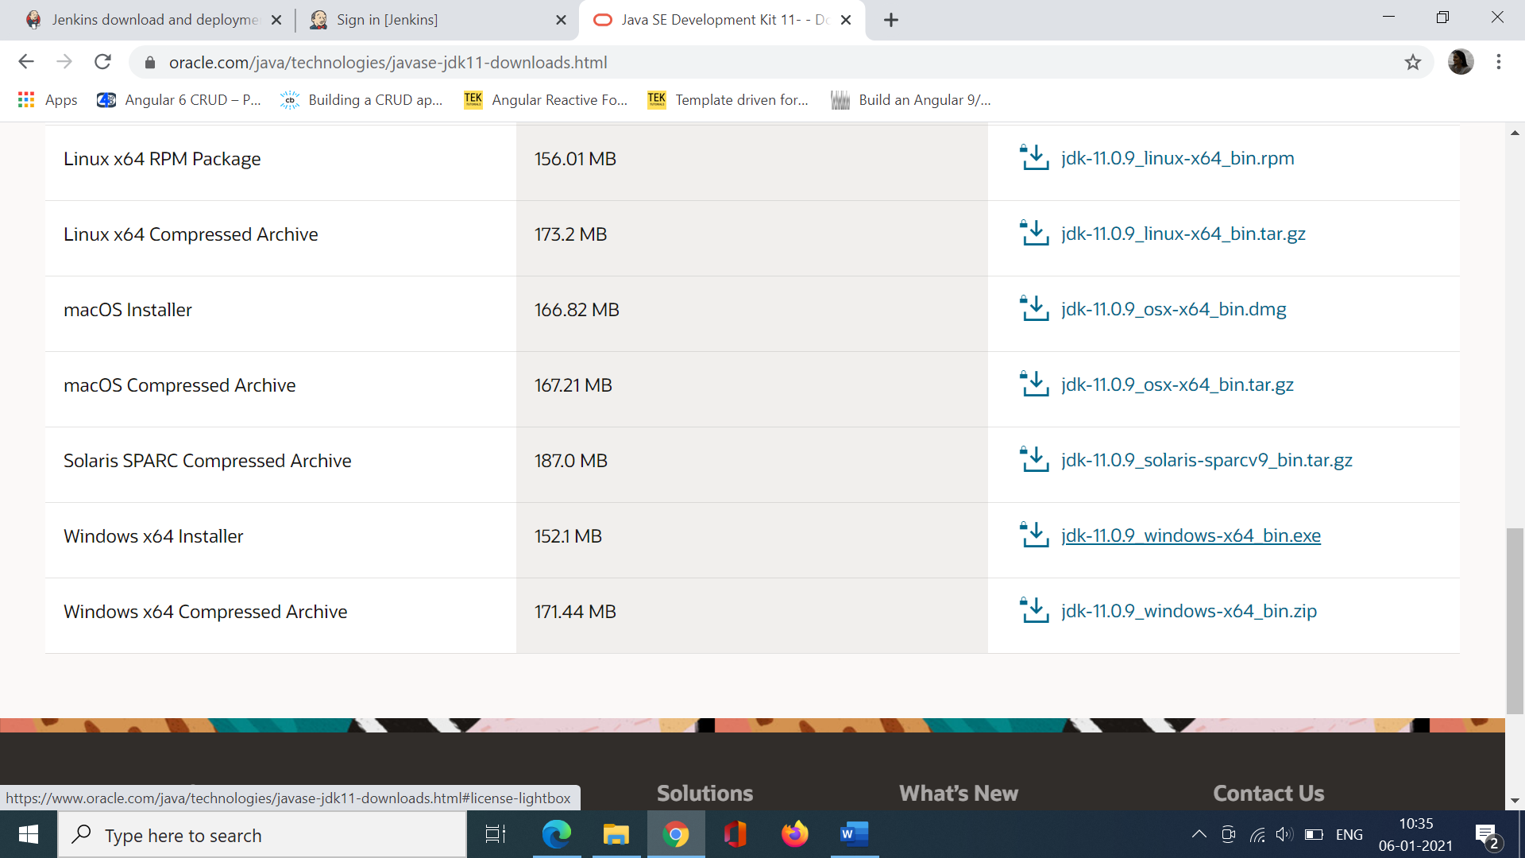

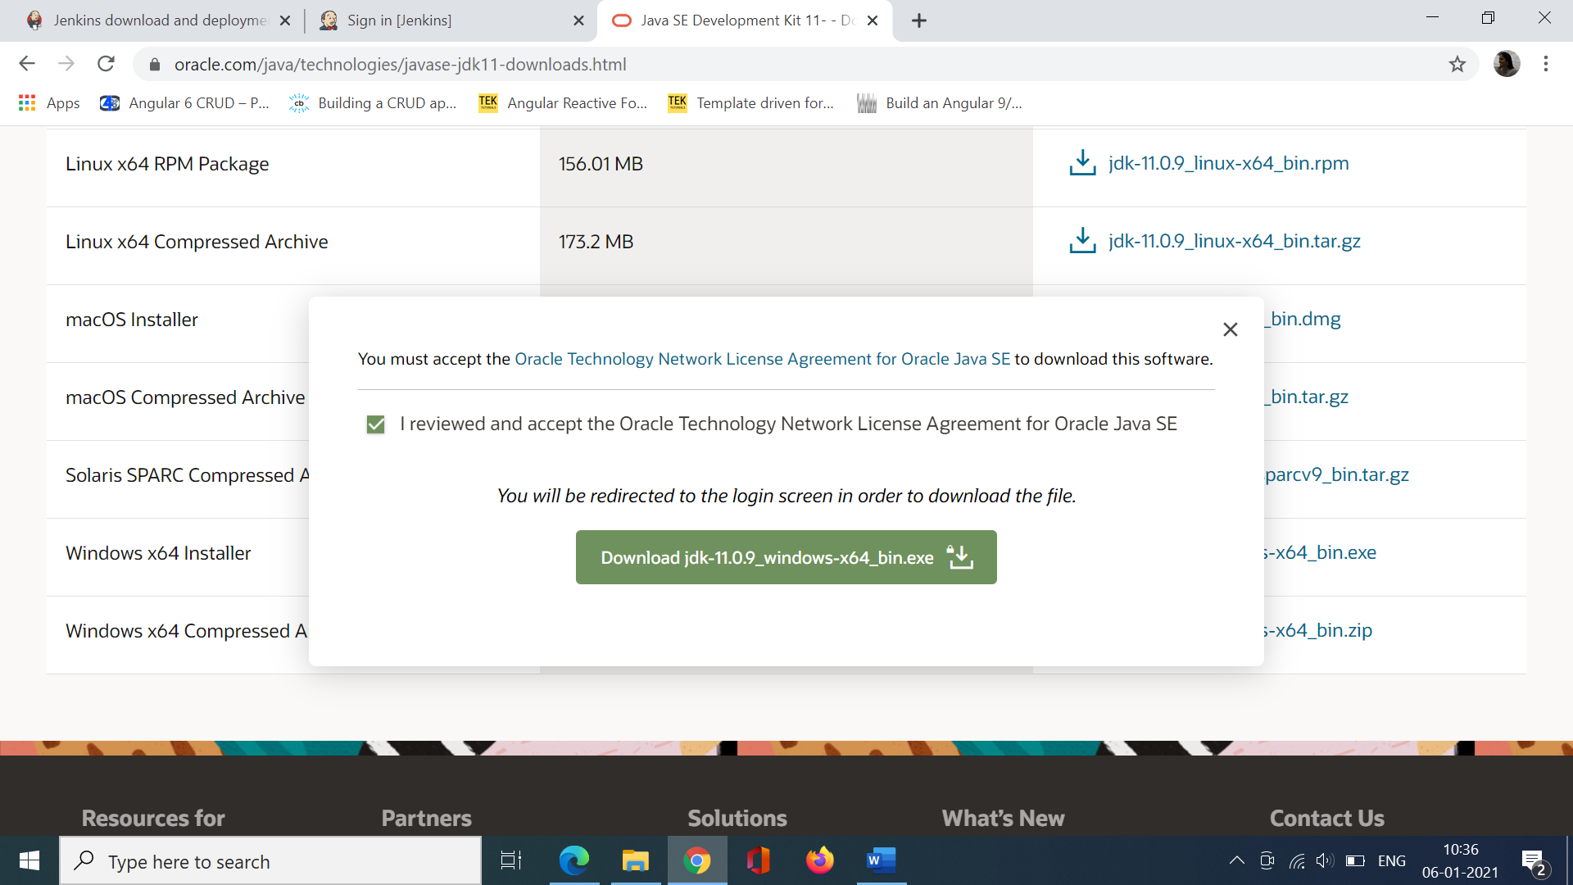

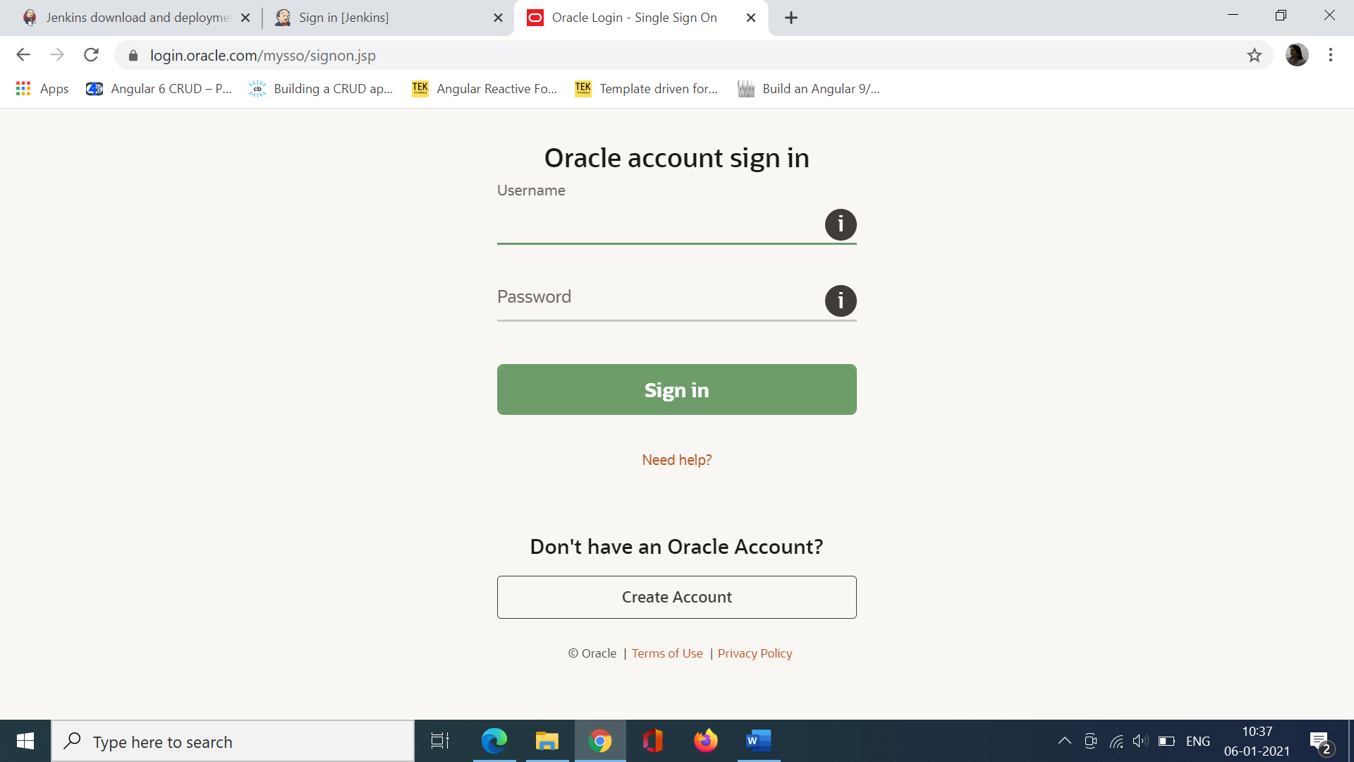

Once you Login the java sdk will be downloaded. Install the JDK file.

Once it is installed successfully goto

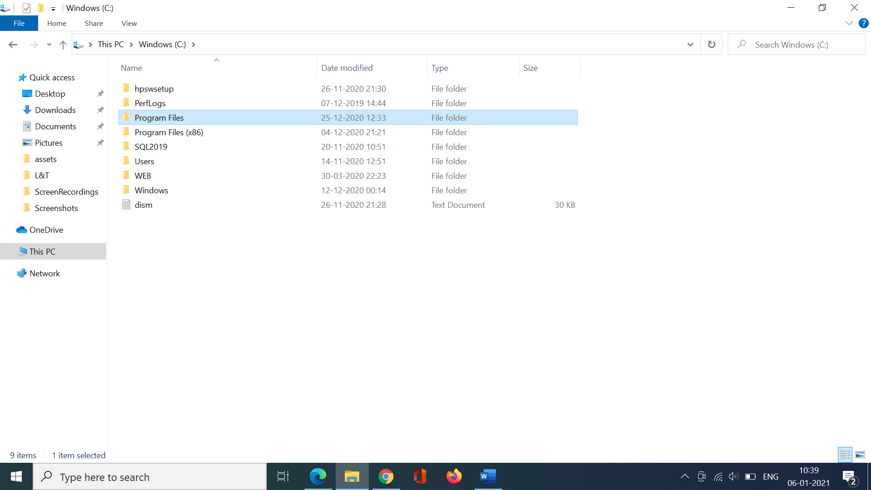

Goto the java folder and you should be able to see the JDK file.

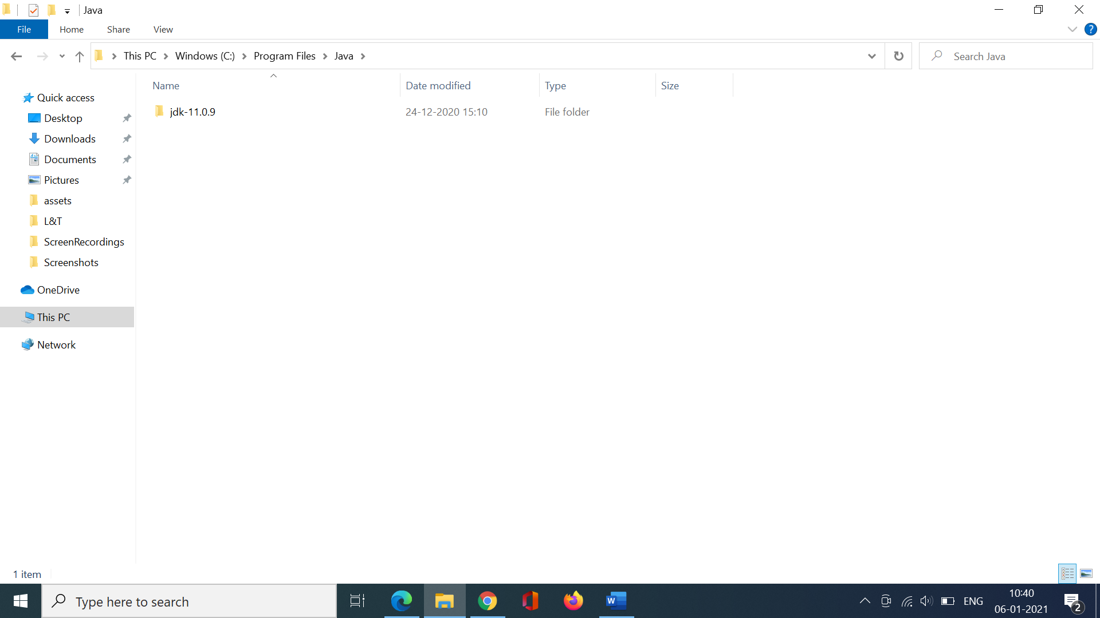

Goto the bin folder and copy the path.

C:\Program Files\Java\jdk-11.0.9\bin

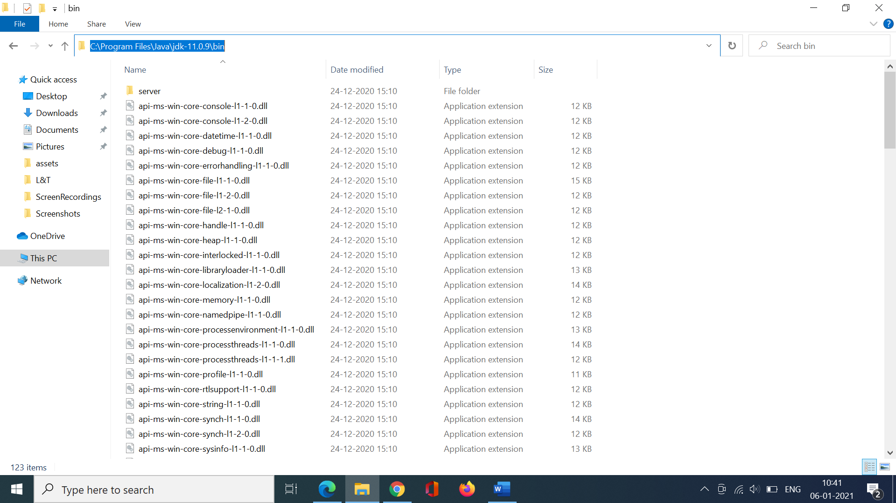

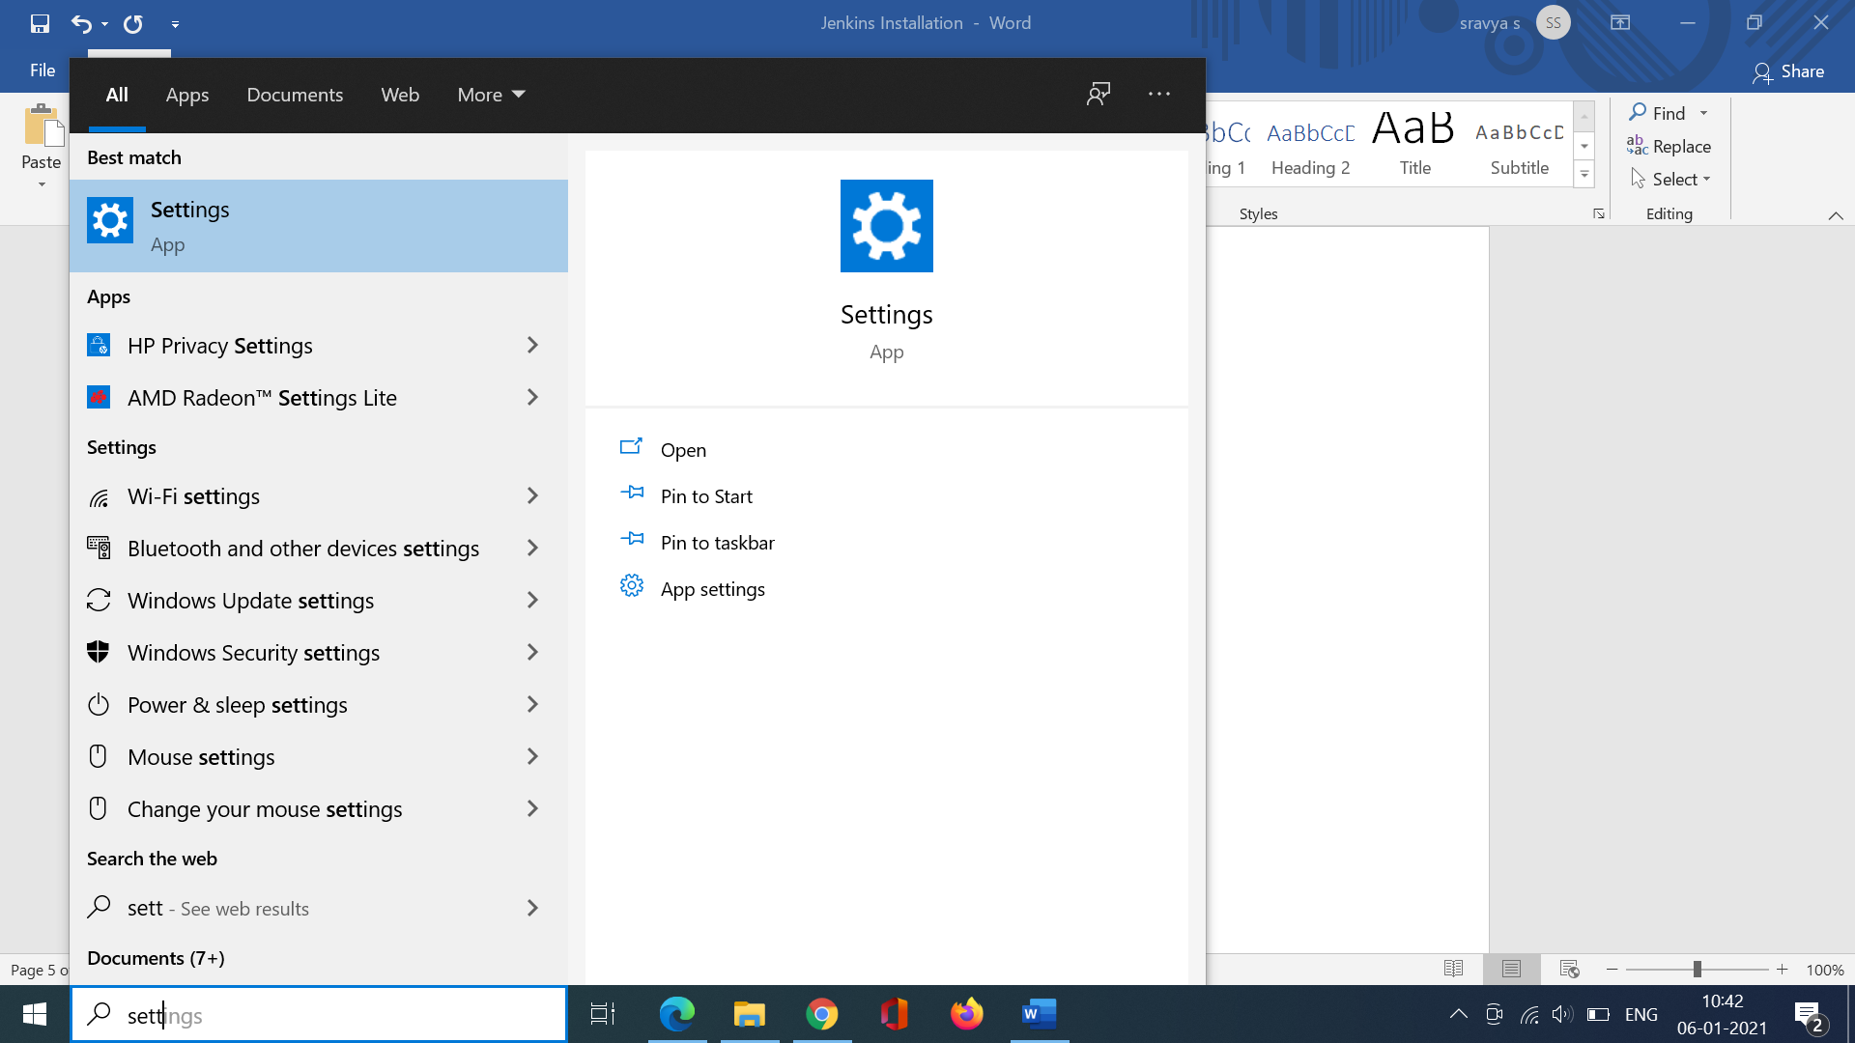

Search for Environment variables

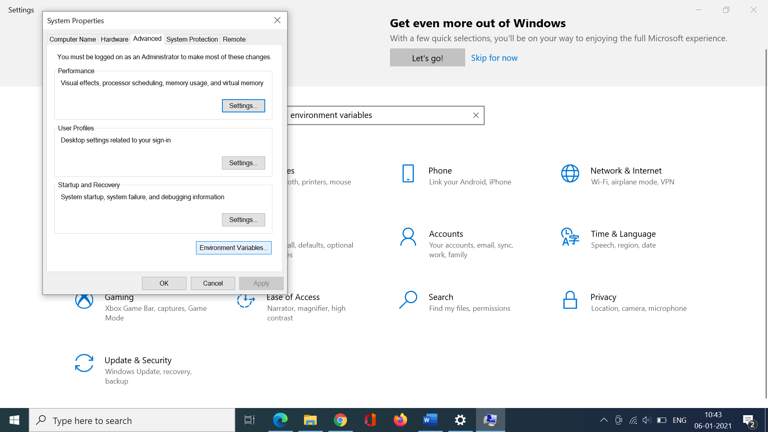

Goto Path. Click Edit. And paste the JDK path if it is not available.

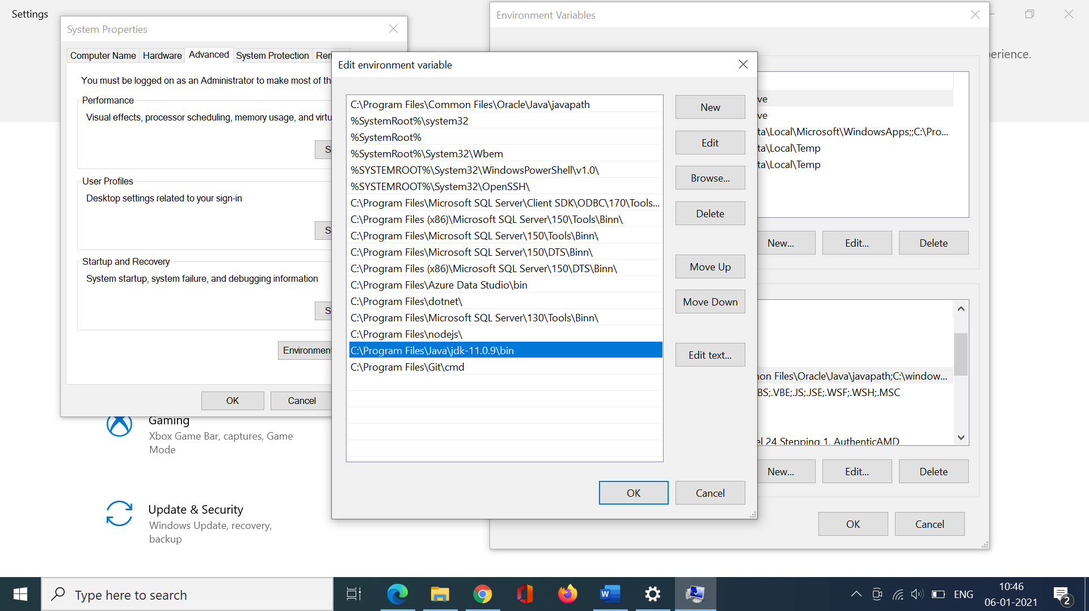

************************************************************

set java path

Environment Varibale--- JAVA_HOME--- > C:\Program Files\Java\jdk-11.0.16.1

Edit Path variable------ %JAVA_HOME%\bin

******************************************************************

Goto <https://www.jenkins.io/> and click on download.

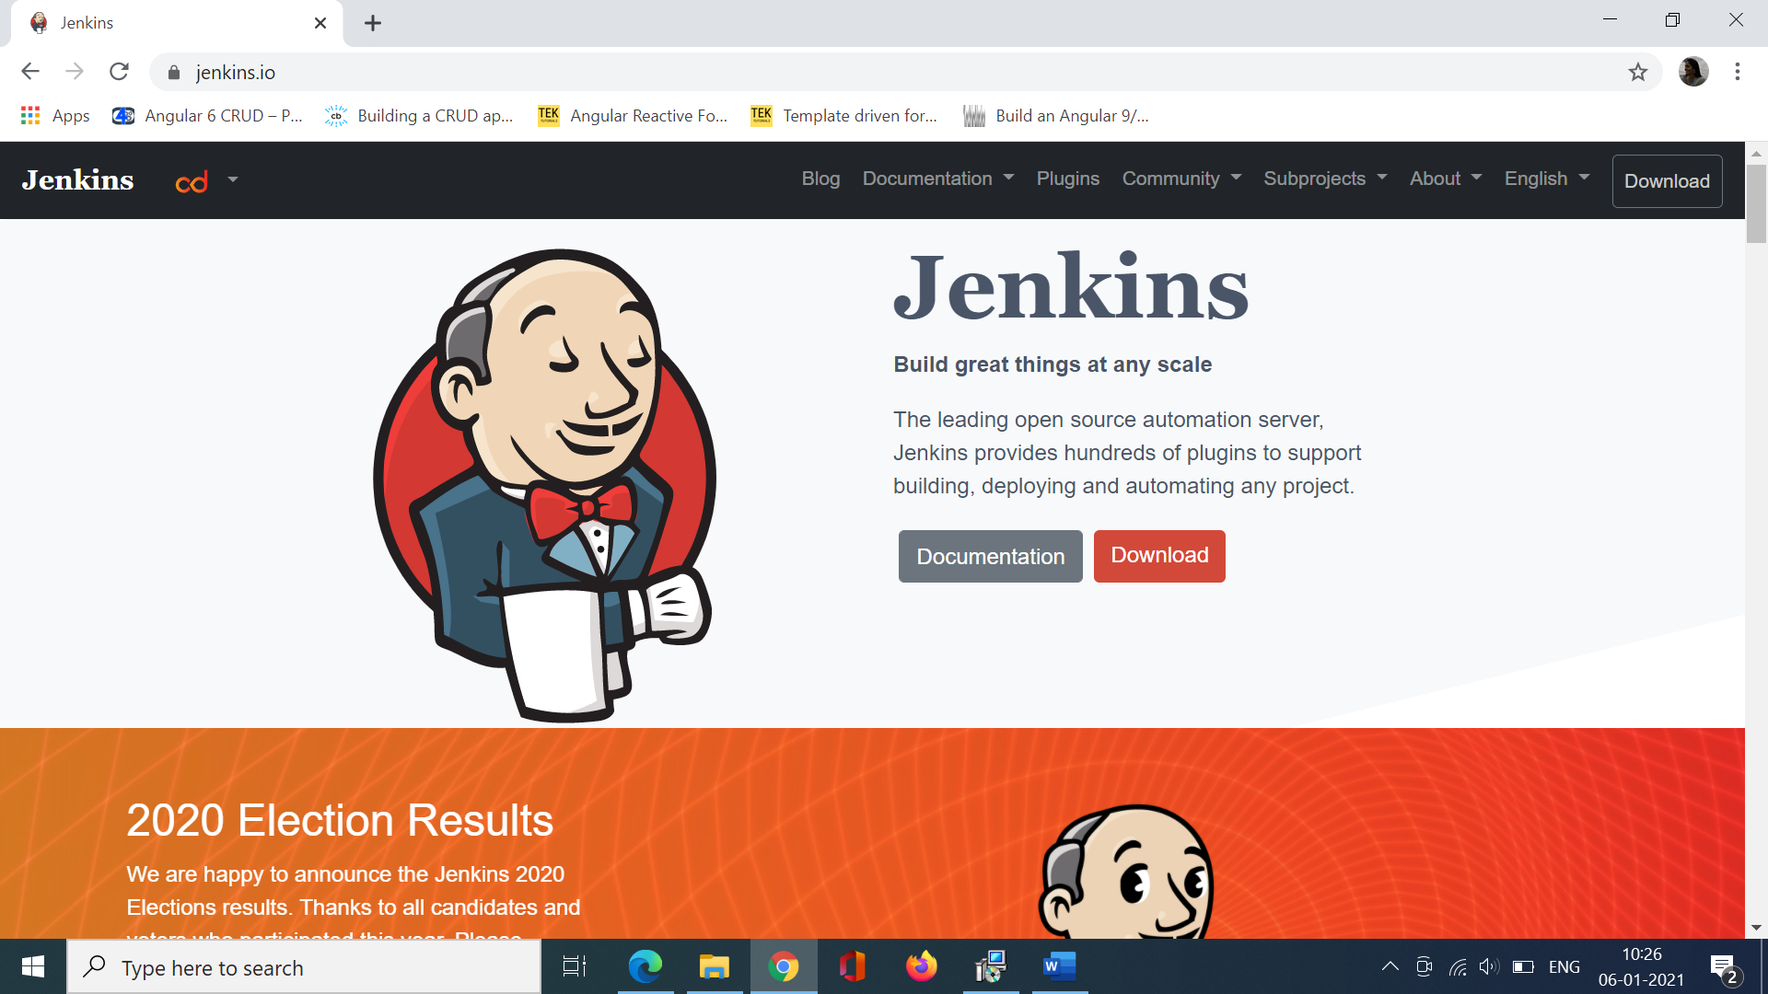

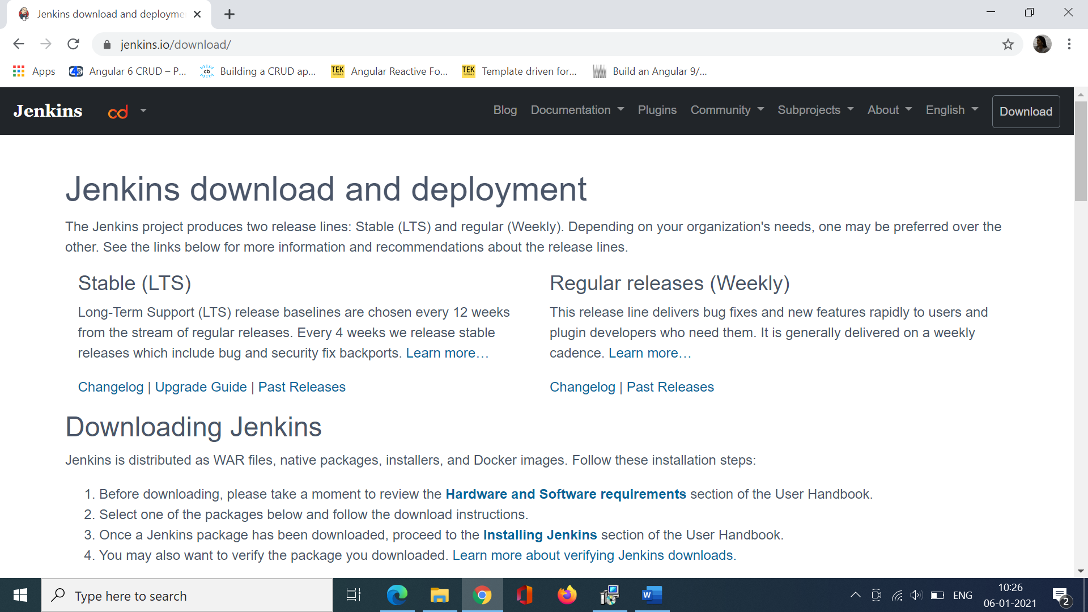

Choose the stable LTS version.

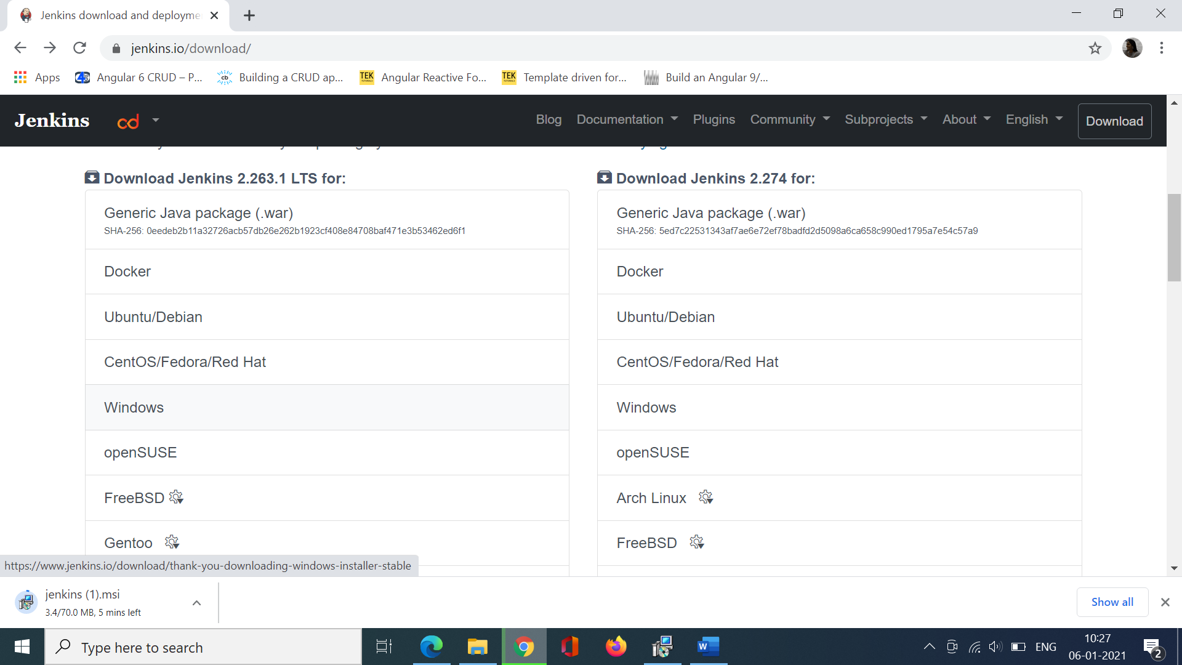

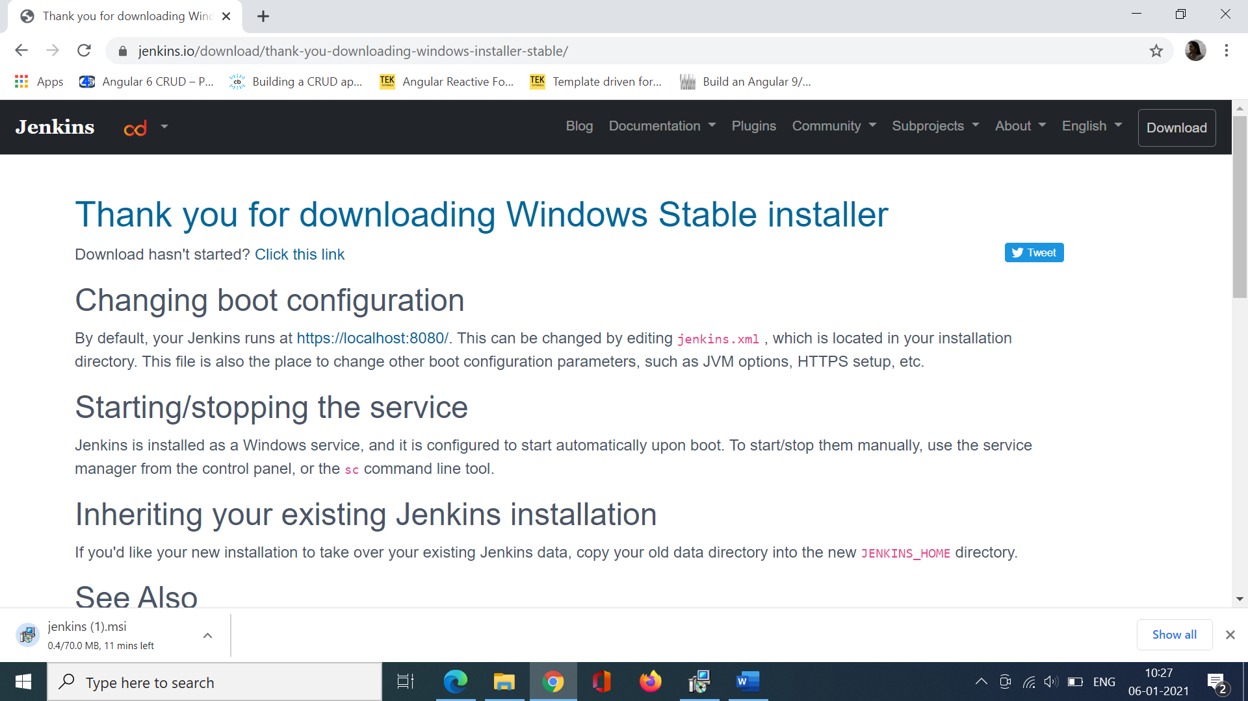

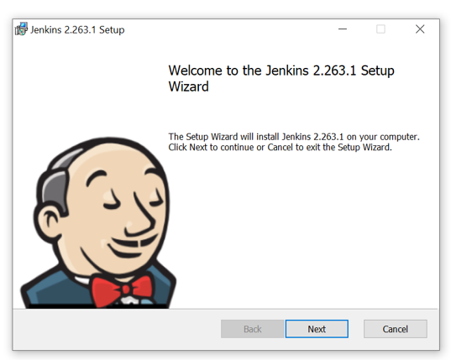

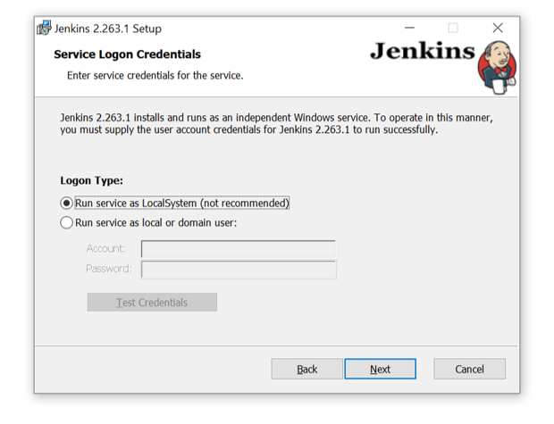

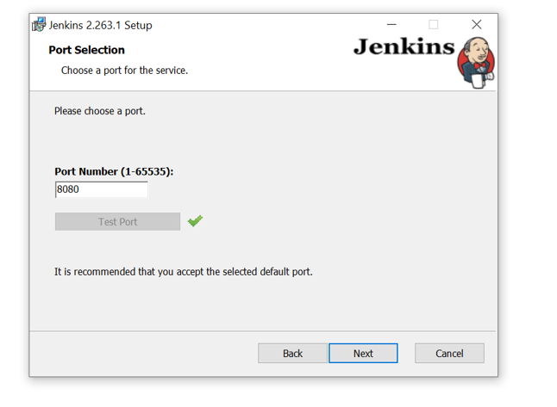

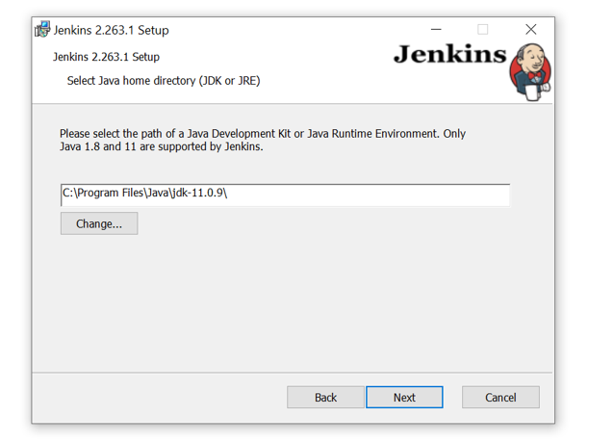

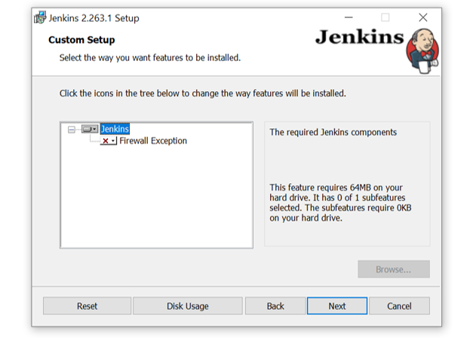

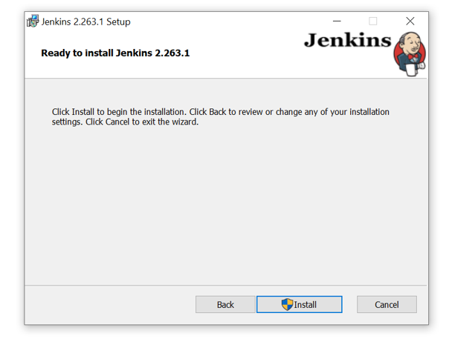

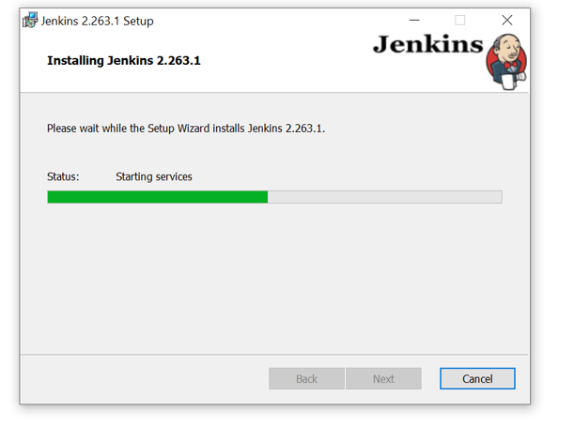

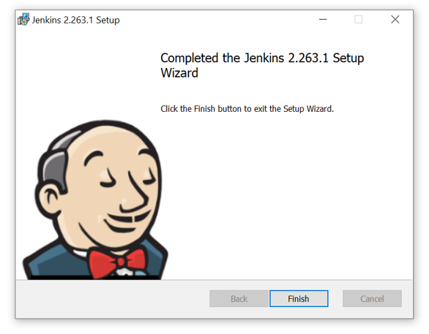

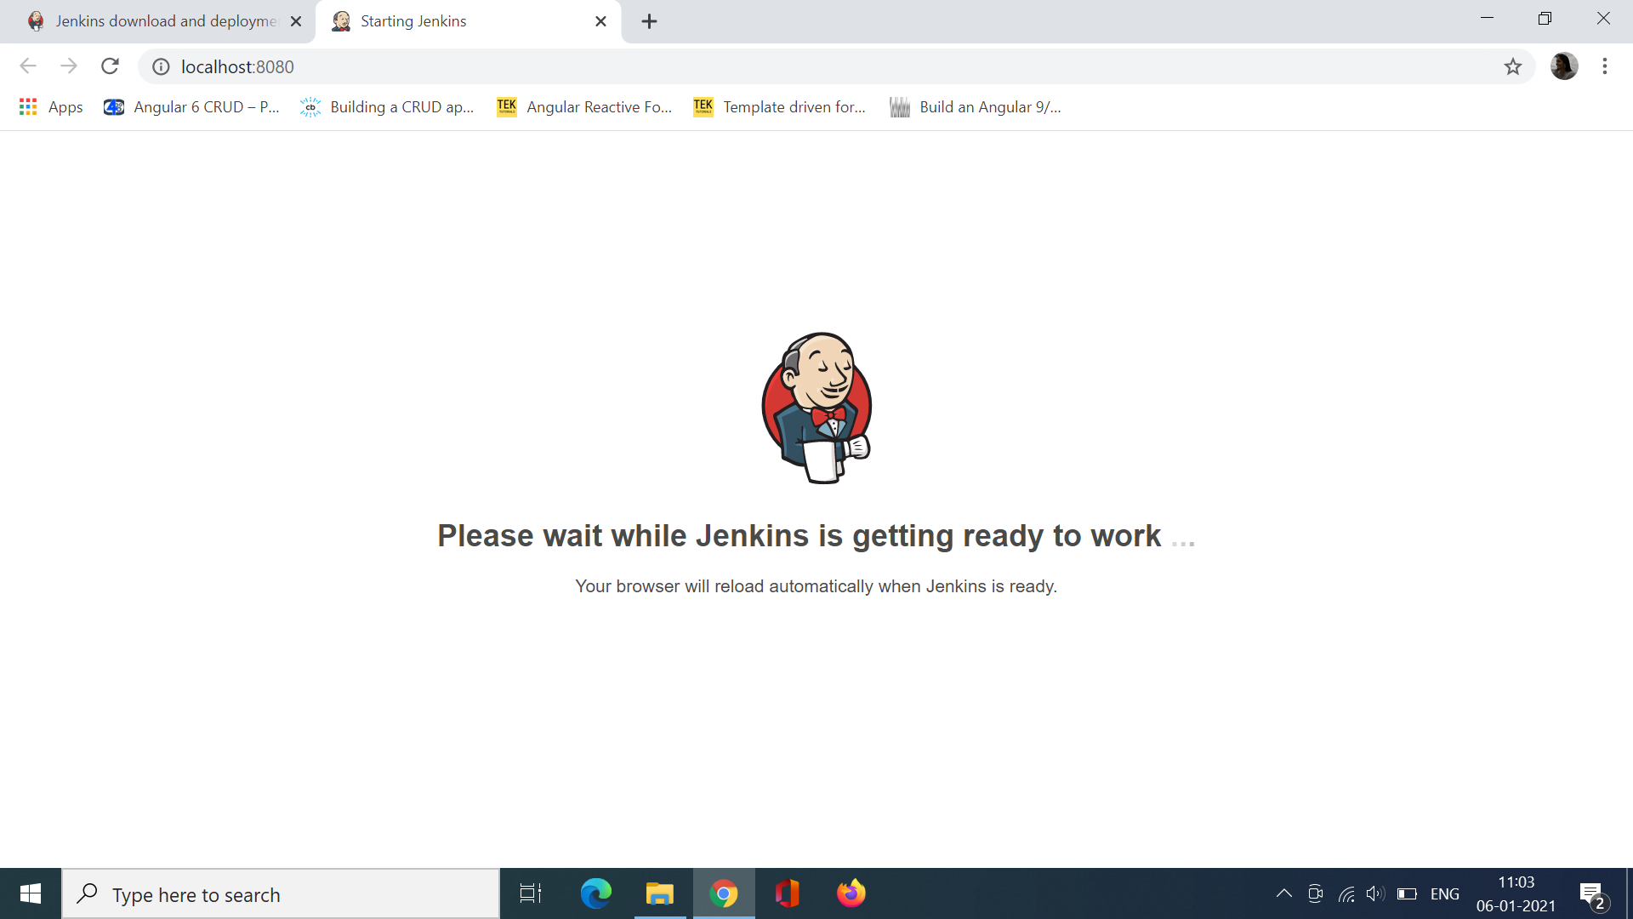

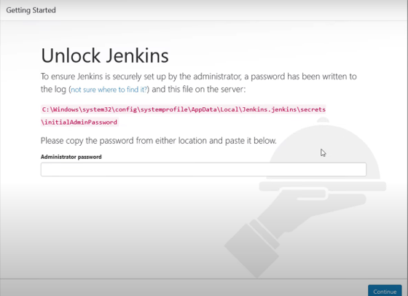

Goto the above location and login through the credentials.

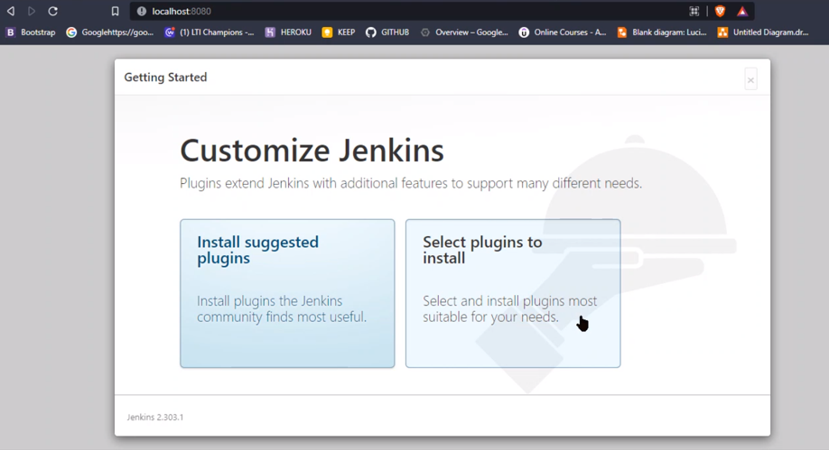

Choose Install Suggested plugins

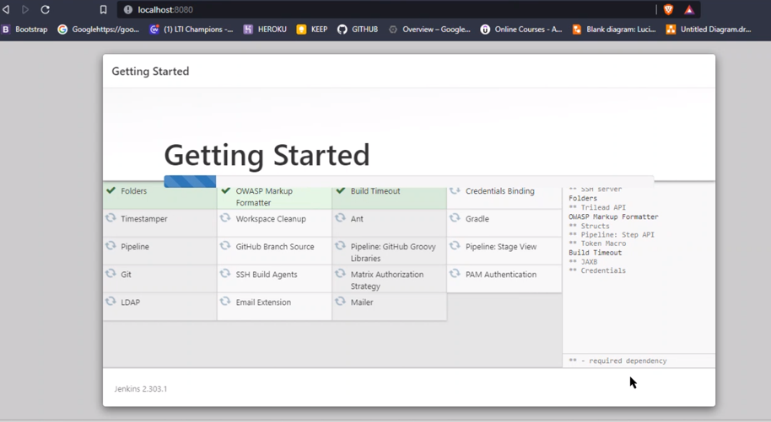

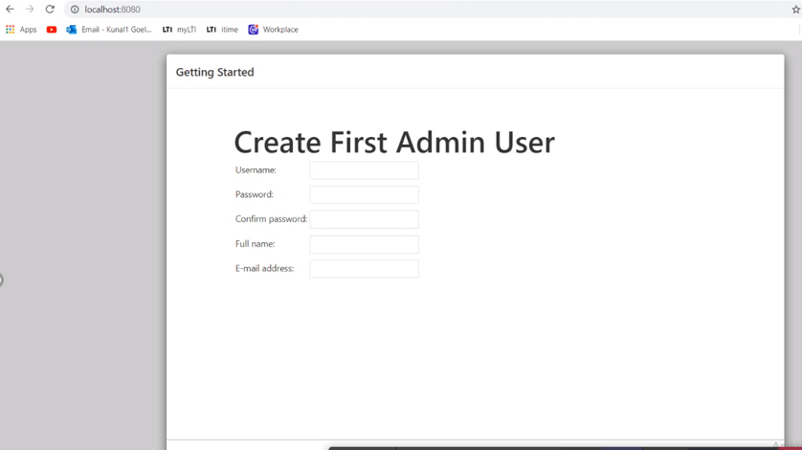

Add User Credentials.

